Jeremy Holloway
CPSC-3220-001
5/23/2019

Homework #1

1.
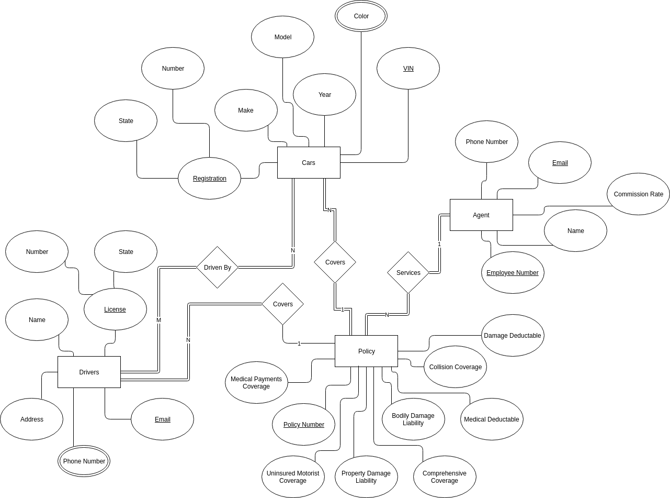
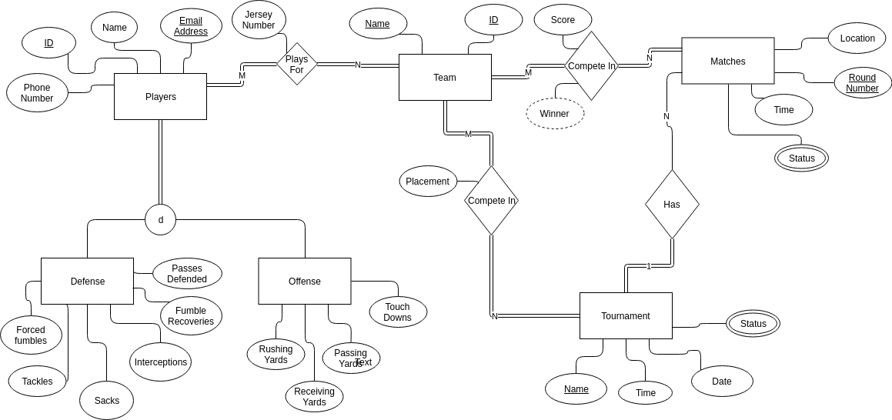
2.

